1) I see that we can add additional images by using VARIATIONS. I added an image to SCBA FRED Systems. The image of the man wearing the yellow jacket is still set to FEATURED and it should be the featured image, but it appears the cart displays the last image uploaded as the main image when you view the product page. It appears it is ignoring the featured image. I tried removing and resetting the featured image and it still seems to ignore it.

See below screenshot. Here no need to add images to the variations. Directly add your first image as featured image and remaining as Product Image. You can add multiple images from Add Image blue button.
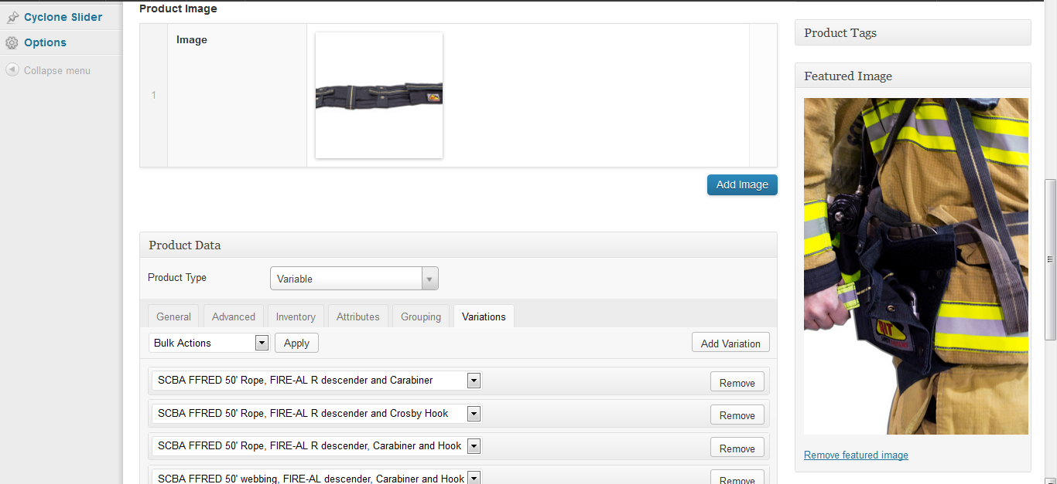
Product Output
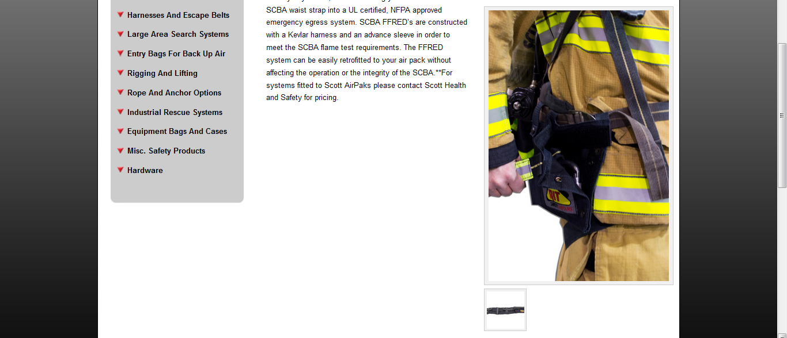

2) For SCBA PRESS Systems, I added image A1144 under variations, but it doesn't appear on the products page in the gallery. I made sure I updated. I did CTRL+F5 to refresh browser.

See below screenshot. Here no need to add images to the variations. Directly add your first image as featured image and remaining as Product Image. You can add multiple images from Add Image blue button.
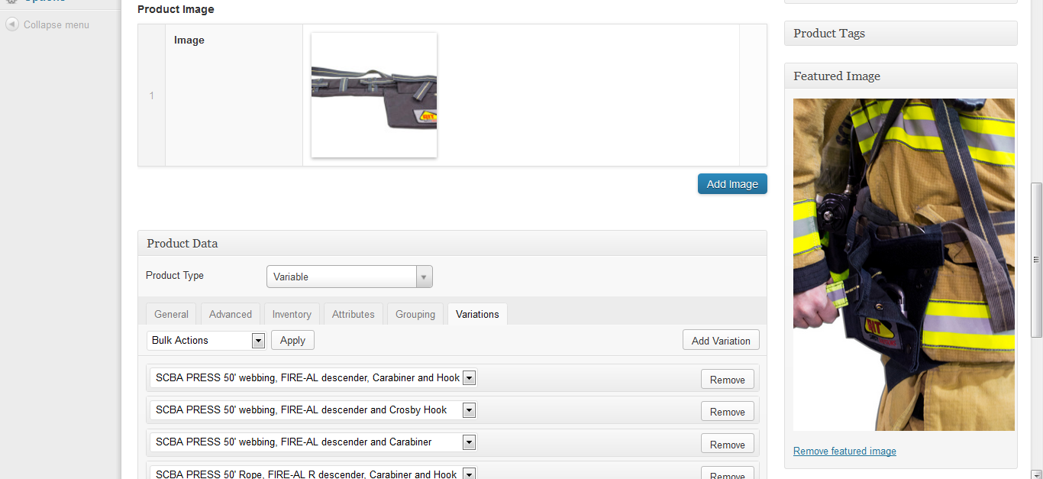
Product output
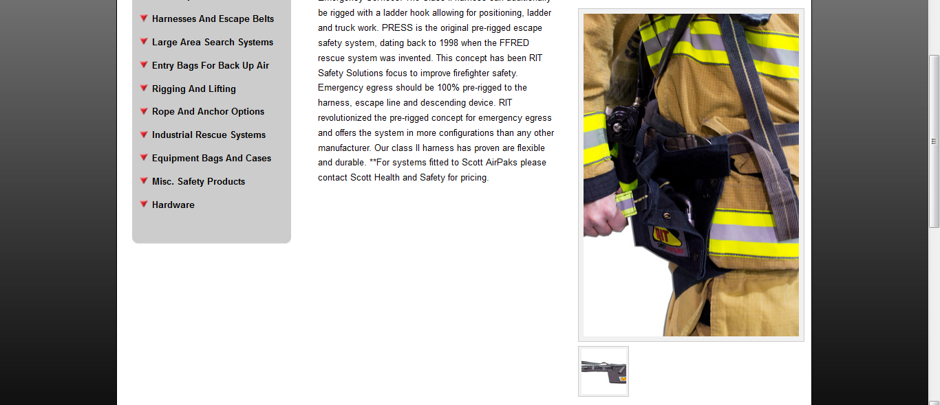

- The "fix" of using variations to add images, but how do we add/detach image for products that have no variations? The client may want to show 5 different angles of a product that has only one variation. For example, product "ladder hook keeper' has only one variation but I have 3 images the client wants to add. I will attach them here: A1119, A1119A, A1119B

We have used image “A1119” as featured image and remaining 2 as product image.
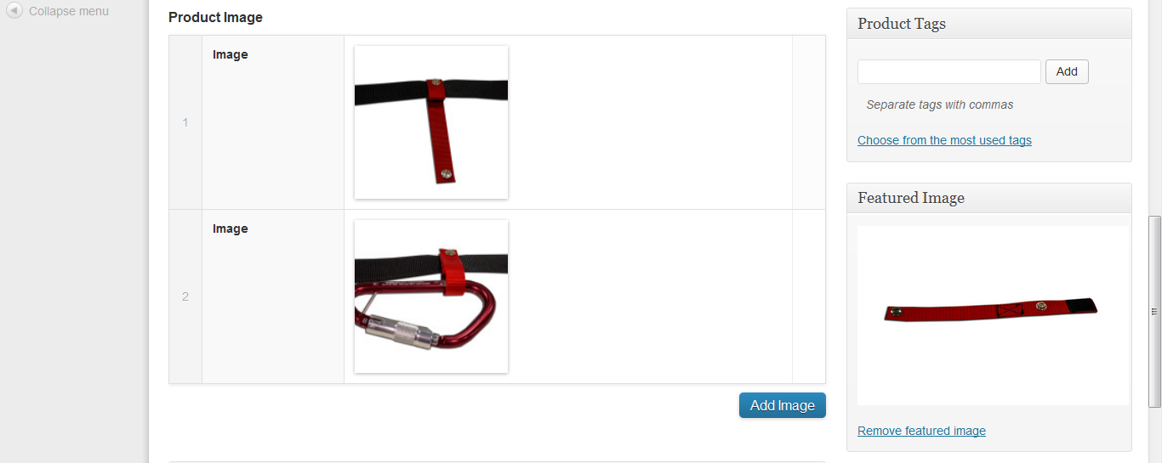
Product Output:
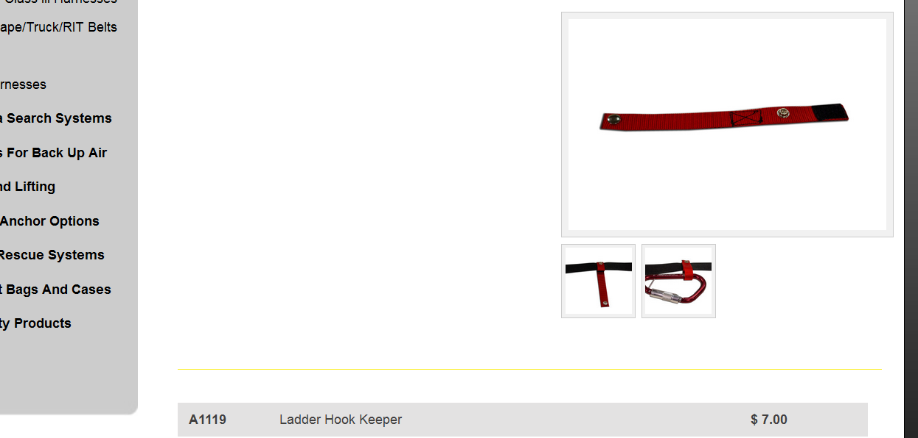

4) Product "RIT Belt" is not showing the second image/variation which is A1127A.jpg.

See screenshot:
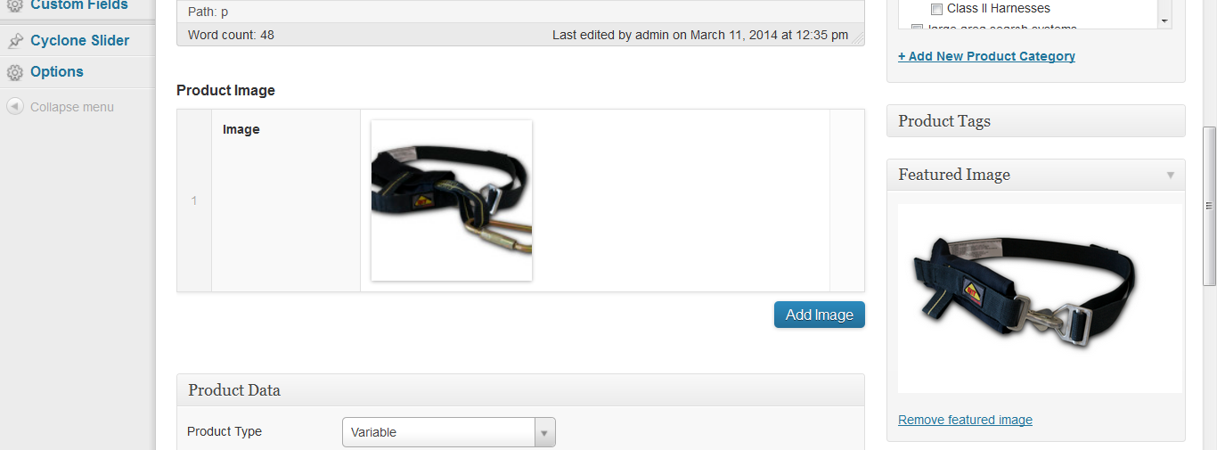
Product Output:
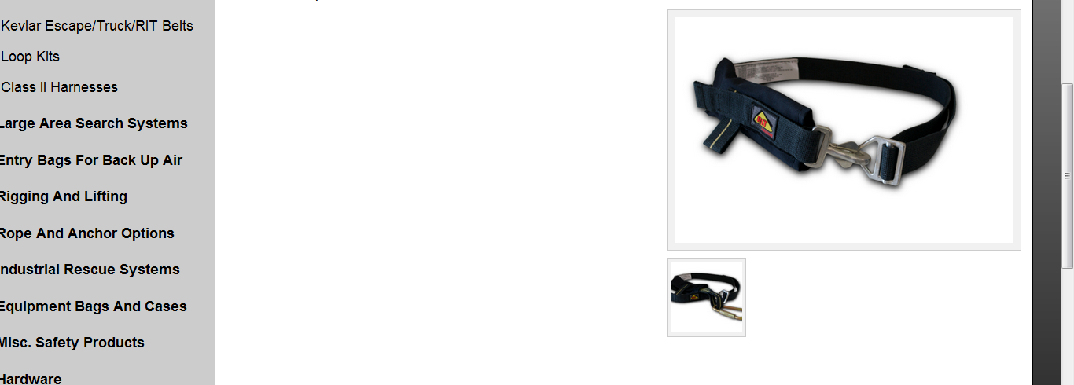

5) Product 'Victim/Rescue EZ Don Harness and Shoulder Bag' had a second image added on the one variation and that image doesn't appear on the live site, but you can see it in the admin area. Also need to add A1198D

See screenshot:
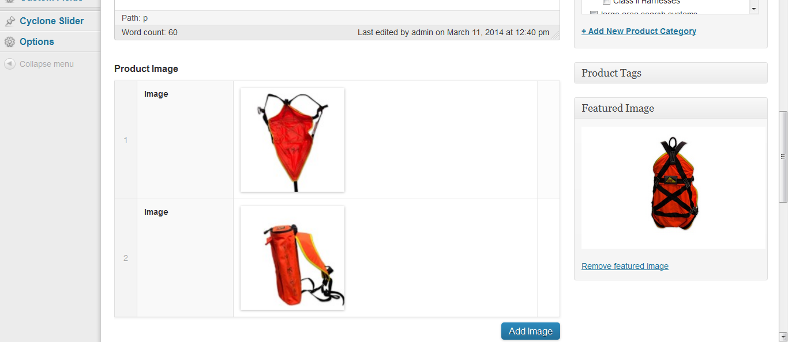
Product Output:
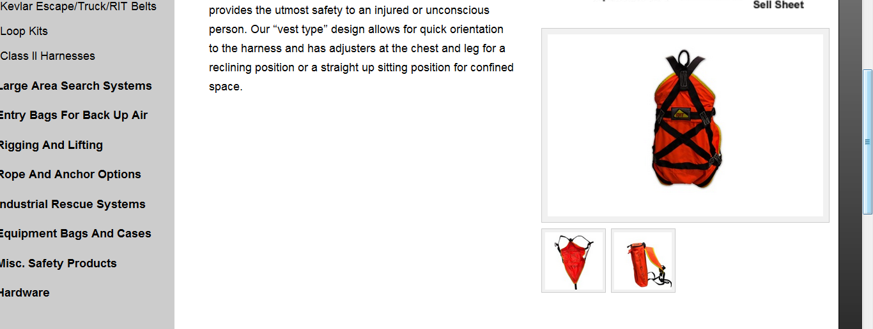

6) Product 'Full Body Class III Harness' - Variations 1 and 2 show fine as does the featured image, but variation 3 doesn't appear on the product page.

See screenshot:
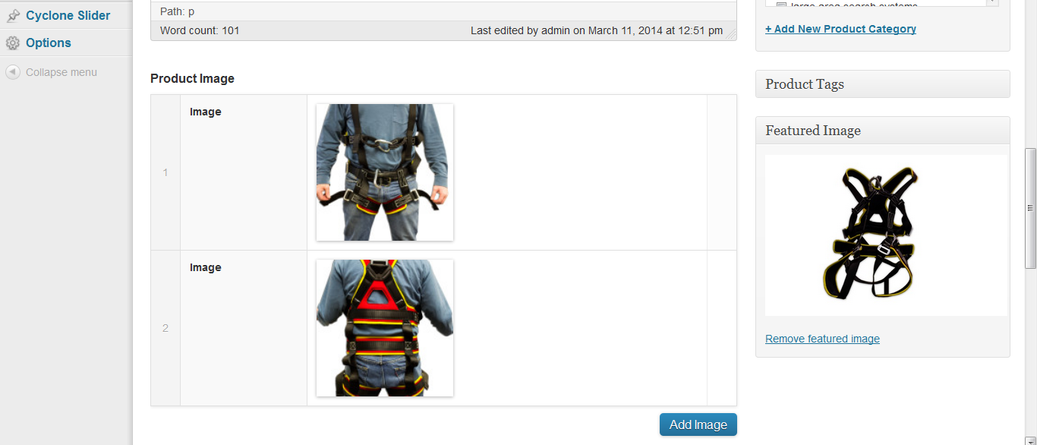
Product Output:
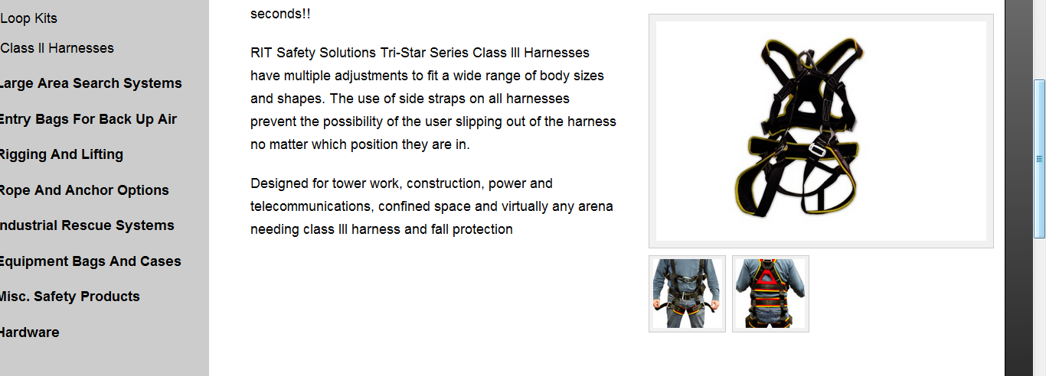

I have an entire page still to look at but I ran out of time today. I am concerned that so many issues are still happening in this cart. Please explain what is happening.

In above screenshots you don’t need to add images to the variations. Directly add your first image as featured image and remaining as Product Image. You can add multiple images from Add Image blue button.

